****Hilliard City School District Preschool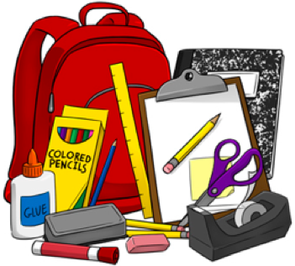

3-4 Year Old Classes

2025-2026 Preschool Supply List

***Please label the following with your child’s name:***

1. Backpack (large enough to hold an 8x11½ notebook and extra clothes; please no wheeled backpacks) – Please put name on front and/or inside.
2. 1 Composition Notebook or Spiral Notebook
3. Personal Hygiene Products (diapers or pull-ups w/ velcro sides & wipes, if applicable)
4. Change of clothes (pants, shirt, socks, underwear - please label clothes with child’s name – put in a Ziploc, please put child’s name on the Ziploc as well)

***Please do not label with your child’s name:***

1. 8 Large or Small Glue Sticks (Elmer’s please)
2. 2 Rolls of Paper Towels
3. 1 Package of Napkins (250 count or less)
4. 2 Boxes of Disposable Cups (5-6 oz. cups work best – please no 3 oz. cups)
5. 1 Bottle of Elmer’s Glue
6. 1 Box Washable Crayola Markers (10 count)
7. 1 Box of Crayola Crayons (16 or 24 count)
8. 1 box of Kleenex

**Please help by also supplying the circled or highlighted items for the students to use collectively throughout the school year (please do not label with child’s name):**

| 1 Package of Expo Dry Erase Markers (4 count) | 1 box of food coloring |
| --- | --- |
| 1 Package of Vis-a-Vis Markers (4 count) | One 4-pack Package of PlayDoh |
| 1 Package of Crayola Write Start Colored Pencils (8 pack) | Small / Large Craft Sticks |
| 1 Crayola Watercolor Washable Paint w/ 8 colors | 1 Package of Brown / White Paper Bags (lunch size) |
| 1 Box of Crayola Pipsqueak Markers | Hand sanitizer |
| 1 Package of Small / Large Paper Plates (non-wax/uncoated) | *Craft Supplies*:  Pipe Cleaners / Pom Poms / Googly Eyes / Small Stamp Pad |
| 1 Package of paper small bowls | Dot-a-Dot Paints |
| 1 Pack of fat colored pencils for young children | 1 Container of Baby Wipes |
| *Ziploc Baggies:*  Gallon Size / Sandwich Size / 2½ Gallon Size | Any sensory items (Choose 1 - cotton balls, hair gel, shaving cream, etc - please keep in original packaging) |
| Fun Stickers (character, holiday, letters, numbers, etc) | 2” Binder |
| 1 Pair of Scissors (kids size, blunt, 5”) | 1 pack of drinking straws |
| 1 Container of Clorox or Lysol Wipes | 1-3 prong plastic folder |

These supplies should last us through the school year. We hope that you will be open to helping us with new supplies should we run out or need new items. We will send a note home if this is the case.

Thank you so much for your contributions!

*Please bring all of these items to your “meet, greet, stay, & play time”