Online Applications

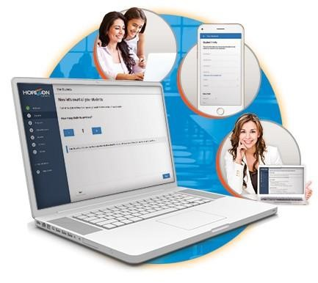
Attention Parents!
You can now submit your Free and Reduced- Price Meal Applications online from any Internet-connected computer, tablet, or smartphone!
■ Complete your application easily, the system guides you through the process
■ Access helpful information every step of the way
■ Use any Internet-connected device to complete your application ■ Receive benefits faster!
©
Horizon

Software

International

|

800.741.7100

|

www.horizonsoftware.co
m

Submit your application today. It's quick and easy!
- Go to our secure website: https://frapps.horizonsolana.com/hilc04
- Follow the onscreen instructions to enter your information
- Receive a confirmation email after submitting
If you have questions, please contact:
Hilliard City Schools Business Office @ (614)921-7000

