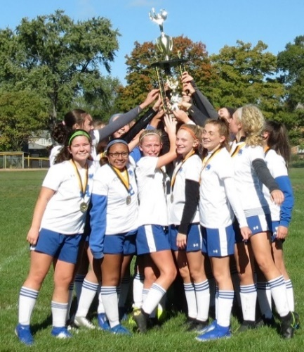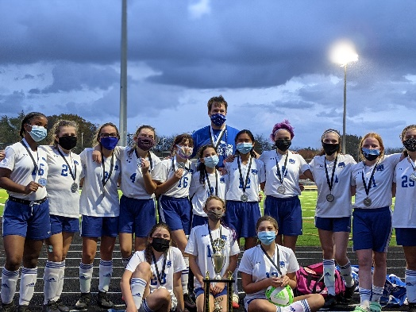

Weaver Middle School Wildcats
Soccer Information Fall 2022

All 7th and 8th Grade Girls that enjoy Soccer and are interested in being part of a positive and competitive team environment are invited to come and join the Weaver Soccer program. The program has a winning tradition as the squad was Central Ohio League Champions in 2019 and were League runners-up in 2020 and semi-finalists last season. We are excited to try and return to the finals this season and want you to be part of that journey.

Informational Meeting - Wednesday, June 1, 6:00 pm: There will be a meeting at 6:00 pm at the Weaver practice fields (behind school) for further information. Interested students and parents are encouraged to attend and learn more information about the program and the upcoming season.

Summer Open Fields: Voluntary open field sessions will be held at the Weaver practice fields for all interested players Sundays and Wednesdays on June 19 and 22; June 26 and 29; Wed July 13; Wed July 27; and Sunday July 31 from 6:30 to 7:30 pm. Brings shoes, shin guards, water and a size 5 soccer ball. Additional dates may be added so keep an eye on the Weaver Athletics calendar.

When does the season start? Team tryouts begin Monday August 1, at 6-7:30 pm and continue through August 4 at that time. We have one team and roster about 18 players. The team is composed of both 7th and 8th grade students. Practices are Mon - Thur, 6-7:30 pm throughout August and matches begin the week that school starts. The season runs through early October when the League Tournament is held.

Questions and/or Sign Up for Email and GroupMe list? If you are interested or have questions, please email or call Coach Eric Plinke at 614-353-6602 or elplinke@live.com to be added to the email list and the GroupMe message system.

Vamos Gatos!

