[](http://wms.hilliardschools.org/)

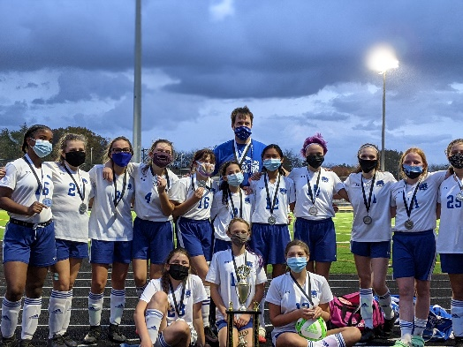

**Weaver Middle School Wildcats**

**Soccer Information Fall 2021**

All 7th and 8th Grade Girls that enjoy Soccer and are interested in being part of a positive and competitive team environment are invited to come and join the Weaver Soccer program. The program has a winning tradition as the squad was Central Ohio League Champions in 2019 and were League runners-up last fall. We are excited to attempt to make a third straight trip to the finals this fall and want you to be part of this journey.

Summer Open Fields: Voluntary open field sessions will be held at the Weaver practice fields for all interested players Sundays and Wednesdays on June 20 and 23; June 27 and 30; July 11 and 14; July 18 and 21; and July 25 and 28 from 6:30 to 7:30 pm.

When does the season start? Team tryouts begin Monday August 2, at 6-7:30 pm and continue through August 4 at that time. We have one team and typically roster between 16 and 19 players. The team is composed of both 7th and 8th grade students. Practices are Mon - Thur, 6-7:30 pm throughout August and matches begin the week that school starts. The season runs through early October when the League Tournament is held.

Questions and/or Sign Up for Email list? If you are interested or have questions, please email or call Coach Eric Plinke at 614-353-6602 or [elplinke@live.com](mailto:elplinke@live.com) to be added to the email list.

Informational Meeting - Monday, May 24, 6:00 pm: There will be a meeting at 6:00 pm at the Weaver practice fields (behind school) for further information. Interested students and parents are encouraged to attend and learn more information about the program and the upcoming season.