Characters costume breakdown:

Foosa – 13
- Students provide
  - black leggings or pants
  - black tank top
  - Black shoe – completely black
- We provide:
  - fabric lengths skirt/belt
  - neck piece
  - black half mask – Order from oriental trading
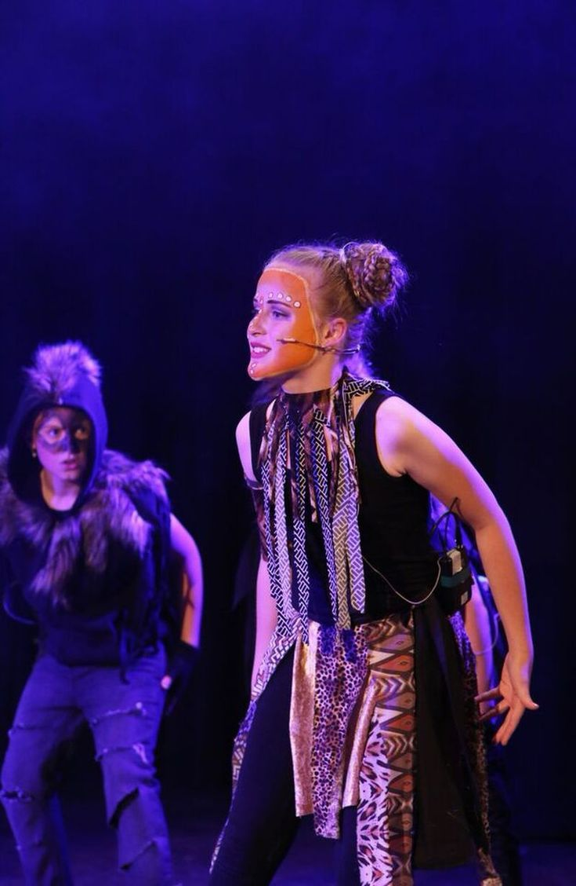

Lemurs – 36

- Students provide
  - light grey sweats
  - light grey T –long sleeved
  - black shoes
  - knee length black socks
- We provide
  - 1 pair black arm warmers
  - white felt chest
  - glasses – black round
  - Beanie hats with ears
  - tails
  - Sash for Maurice
  - binkie with a strap for Mort

Animal Control – renting costume from Debbie

Zoo visitors

- Students provide
  - sunglasses
  - camera around neck – only a few
  - backpacks – a few
  - shorts (not athletic) or skirts in the following colors:
    - red, pink, yellow, orange
  - tops/shirts in same color palette – no logos, writing, sequins, pictures
    - prints or patterns good
  - plain black shoe
- We provide
  - balloons, pennants, cotton candy- ask zoo for maps

New Yorkers
- Costumes to resemble the following characters: We will assign specifics
  - Office workers
  - Construction workers
  - Homeless
  - Runners
  - High Fashion
  - Skater boy
  - All black/punk

Zoo keepers – 3 – ask the zoo for 3 costumes/ shirt, vest and hat
- Students provide
  - khaki shorts/pants
  - polo shirt https://www.amazon.com/dp/B017V65WKS/ref=twister_B071VNVBZQ?th=1
  - black shoe
  - black short sock or no show sock
- We provide
  - hat
  - maybe khaki vest?
  - animal print bandanas?

Candy –
- Student provides professional outfit

Cameraman

- Students provides pants and plain T

King Julien – measure his head
- Student provides
  - lemur base

- We provide
  - Headpiece
  - sequined felt chest
  - strip belt of bright African fabrics

Lionesses – (6)

- Student Provides
  - Black leggings
  - black tank
- We provide
  - faux fur stole
  - anklets
  - wristlets
  - tulle skirt in tan, gold sparkle
  - ear headbands

Penguins – 6

- Rent whole costume from Debbie Hamrick
- Students provide
  - black leggings
  - black tank
  - black shoes

Old Lady

- Student provides
  - skirt and blouse or dress old fashioned
  - cardigan sweater
  - black shoes
  - oversized trouser socks
- We provide
  - old white wig
  - purse
  - crocheted white cape

Police officers – 2 – rent from Debbie

- Rent costumes from Debbie

Servers

- Students provide
  - black leggings
  - white buttoned shirt
  - black shoes
- We provide
  - red apron
  - steaks on a platter

Steaks –

- Students provide
  - black leggings
  - black tank
  - black shoes
- We provide
  - cardboard steaks giant size

Subway announcer – measure jacket size

- Student provides
  - white buttoned down shirt
  - navy or black skirt or pants
  - black shoes
- We provide
  - blazer
  - conductors cap

Ship captain

- Student provides
  - black leggings or pants
  - black shoes

- We provide
  - sailor top
  - sailor cap

Mason the Monkey –

- Student provides
  - black pants
  - black long sleeved T
  - black shoes
- We provide
  - vest
  - collar and cuffs
  - ears
  - tail
  - bowler

Alex – measure waist
- Student provides
  - gold lame shirt – long-sleeved
  - black/tan dance flats
- We provide
  - Wig
  - ears
  - tail
  - vest of fur
  - bell bottom pants – to order from Amazon after measurments
Marty
- Student provides
  - black combat boots
  - pants https://www.amazon.com/Zubaz-Classic-Printed-Athletic-Lounge/dp/B002KPHXGM/ref=sr_1_6?ie=UTF8&qid=1547325399&sr=8-6&keywords=zebra+sweat+pants
- We provide
  - zebra striped shirt
  - zebra striped vest

Melman
- Student provides
  - black dance flats
  - brown Bermuda shorts
  - mustard colored T
We provide
  - golden vest
  - ears out of hair and tail
  - green bow tie
  - leggings add giraffe print with paint

Gloria – measure for dress size
- Student provides
  - grey opaque tights
  - black shoes
- We provide
  - dress – grey with pink embellishments and pink under skirt
  - pink wig

